**Cyber bullying in online games（如何应对网络游戏的霸凌）**

Question 8 (Sub-question 5):Automatically identify and block illegal words (overall evaluation, 1 point is very bad) [Matrix question]

|  |  |  |  |  |  |  |  |  |
| --- | --- | --- | --- | --- | --- | --- | --- | --- |
| X\Y | don't know unknown | very worse | poor worse | normal | better nice | very nice very nice | Subtotal | The average score |
| 14 and below (under 16 years old) | 2 (22.22%) | 1 (11.11%) | 1 (11.11%) | 0 (0.00%) | 2 (22.22%) | 3 (33.33%) | 9 | 3.71 |
| 14-18 | 5 (23.81%) | 1 (4.76%) | 1 (4.76%) | 8 (38.10%) | 5 (23.81%) | 1 (4.76%) | twenty one | 3.25 |
| 18-26 | 11 (9.32%) | 10 (8.47%) | 27 (22.88%) | 39 (33.05%) | 24 (20.34%) | 7 (5.93%) | 118 | 2.92 |
| 26-35 | 3 (8.11%) | 7 (18.92%) | 9 (24.32%) | 6 (16.22%) | 10 (27.03%) | 2 (5.41%) | 37 | 2.74 |
| 35-55 | 4 (33.33%) | 0 (0.00%) | 0 (0.00%) | 4 (33.33%) | 4 (33.33%) | 0 (0.00%) | 12 | 3.5 |
| 55 and above (over 55 years old) | 3 (75%) | 0 (0.00%) | 0 (0.00%) | 0 (0.00%) | 0 (0.00%) | 1 (25%) | 4 | 5 |

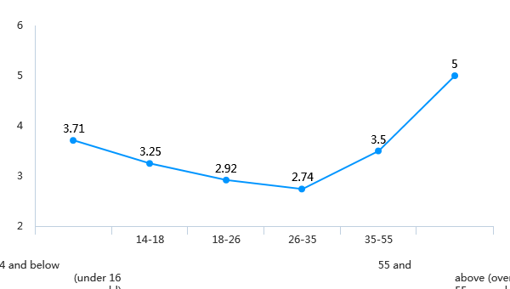

Question 10 (Sub-question 5):Report to the operator (overall evaluation, 1 point is very bad) [Matrix question]

|  |  |  |  |  |  |  |  |  |
| --- | --- | --- | --- | --- | --- | --- | --- | --- |
| X\Y | don't know unknow | very worse | poor worse | normal | better nice | very nice very nice | Subtotal | The average score |
| 14 and below (under 16 years old) | 2 (22.22%) | 0 (0.00%) | 1 (11.11%) | 1 (11.11%) | 3 (33.33%) | 2 (22.22%) | 9 | 3.86 |
| 14-18 | 4 (19.05%) | 2 (9.52%) | 1 (4.76%) | 6 (28.57%) | 6 (28.57%) | 2 (9.52%) | twenty one | 3.29 |
| 18-26 | 10 (8.47%) | 10 (8.47%) | 29 (24.58%) | 30 (25.42%) | 32 (27.12%) | 7 (5.93%) | 118 | 2.97 |
| 26-35 | 4 (10.81%) | 6 (16.22%) | 7 (18.92%) | 6 (16.22%) | 11 (29.73%) | 3 (8.11%) | 37 | 2.94 |
| 35-55 | 4 (33.33%) | 0 (0.00%) | 0 (0.00%) | 3 (25%) | 5 (41.67%) | 0 (0.00%) | 12 | 3.62 |
| 55 and above (over 55 years old) | 3 (75%) | 0 (0.00%) | 0 (0.00%) | 0 (0.00%) | 0 (0.00%) | 1 (25%) | 4 | 5 |

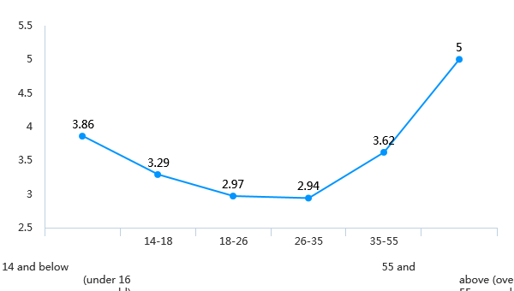

Question 12 (Sub-question 5):Player education, through creating a good game community atmosphere, allowing players to consciously maintain the game environment (overall evaluation, 1 point is very bad) )) [Matrix question]

|  |  |  |  |  |  |  |  |  |
| --- | --- | --- | --- | --- | --- | --- | --- | --- |
| X\Y | don't know unknow | very worse | poor worse | normal | better nice | very nice very nice | Subtotal | The average score |
| 14 and below (under 16 years old) | 4 (44.44%) | 0 (0.00%) | 1 (11.11%) | 3 (33.33%) | 1 (11.11%) | 0 (0.00%) | 9 | 3 |
| 14-18 | 6 (28.57%) | 0 (0.00%) | 0 (0.00%) | 6 (28.57%) | 6 (28.57%) | 3 (14.29%) | twenty one | 3.8 |
| 18-26 | 15 (12.71%) | 17 (14.41%) | 25 (21.19%) | 35 (29.66%) | 19 (16.10%) | 7 (5.93%) | 118 | 2.75 |
| 26-35 | 4 (10.81%) | 8 (21.62%) | 6 (16.22%) | 7 (18.92%) | 9 (24.32%) | 3 (8.11%) | 37 | 2.79 |
| 35-55 | 5 (41.67%) | 1 (8.33%) | 0 (0.00%) | 3 (25%) | 2 (16.67%) | 1 (8.33%) | 12 | 3.29 |
| 55 and above (over 55 years old) | 3 (75%) | 0 (0.00%) | 0 (0.00%) | 0 (0.00%) | 0 (0.00%) | 1 (25%) | 4 | 5 |

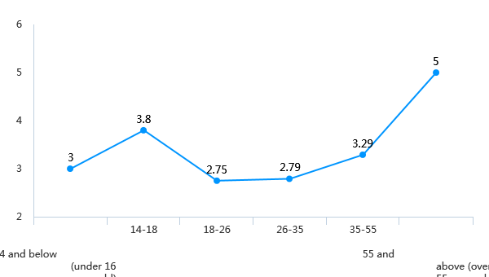

Question 14 (Sub-question 5):automated disciplinary system and player reform system in League of Legends (overall evaluation, 1 point is very bad) [Matrix question]

|  |  |  |  |  |  |  |  |  |
| --- | --- | --- | --- | --- | --- | --- | --- | --- |
| X\Y | don't know unknow | very worse | poor worse | normal | better nice | very nice very nice | Subtotal | The average score |
| 14 and below (under 16 years old) | 1 (33.33%) | 0 (0.00%) | 0 (0.00%) | 2 (66.67%) | 0 (0.00%) | 0 (0.00%) | 3 | 3 |
| 14-18 | 2 (18.18%) | 0 (0.00%) | 0 (0.00%) | 5 (45.45%) | 2 (18.18%) | 2 (18.18%) | 11 | 3.67 |
| 18-26 | 8 (12.70%) | 6 (9.52%) | 12 (19.05%) | 17 (26.98%) | 13 (20.63%) | 7 (11.11%) | 63 | 3.05 |
| 26-35 | 4 (16.67%) | 1 (4.17%) | 6 (25%) | 5 (20.83%) | 5 (20.83%) | 3 (12.5%) | twenty four | 3.15 |
| 35-55 | 1 (33.33%) | 0 (0.00%) | 1 (33.33%) | 0 (0.00%) | 1 (33.33%) | 0 (0.00%) | 3 | 3 |
| 55 and above (over 55 years old) | 0 (0.00%) | 0 (0.00%) | 0 (0.00%) | 0 (0.00%) | 0 (0.00%) | 1 (100%) | 1 | 5 |

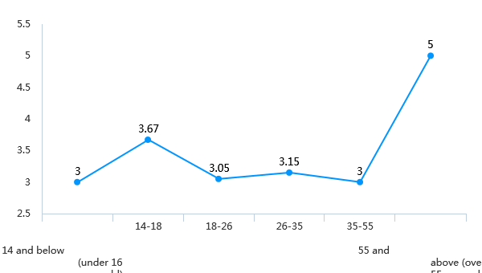

Question 16 (Sub-question 5):Block user, delete post and/or flag content when toxic behavior is occurring (overall evaluation, 1 point is very bad) [Matrix question]

|  |  |  |  |  |  |  |  |  |
| --- | --- | --- | --- | --- | --- | --- | --- | --- |
| X\Y | don't know unknow | very worse | poor worse | normal | better nice | very nice very nice | Subtotal | The average score |
| 14 and below (under 16 years old) | 2 (22.22%) | 0 (0.00%) | 0 (0.00%) | 2 (22.22%) | 3 (33.33%) | 2 (22.22%) | 9 | 4 |
| 14-18 | 6 (28.57%) | 0 (0.00%) | 2 (9.52%) | 9 (42.86%) | 3 (14.29%) | 1 (4.76%) | twenty one | 3.2 |
| 18-26 | 17 (14.41%) | 8 (6.78%) | 19 (16.10%) | 38 (32.20%) | 31 (26.27%) | 5 (4.24%) | 118 | 3.06 |
| 26-35 | 5 (13.51%) | 3 (8.11%) | 3 (8.11%) | 10 (27.03%) | 11 (29.73%) | 5 (13.51%) | 37 | 3.38 |
| 35-55 | 3 (25%) | 1 (8.33%) | 0 (0.00%) | 5 (41.67%) | 3 (25%) | 0 (0.00%) | 12 | 3.11 |
| 55 and above (over 55 years old) | 3 (75%) | 0 (0.00%) | 0 (0.00%) | 0 (0.00%) | 0 (0.00%) | 1 (25%) | 4 | 5 |

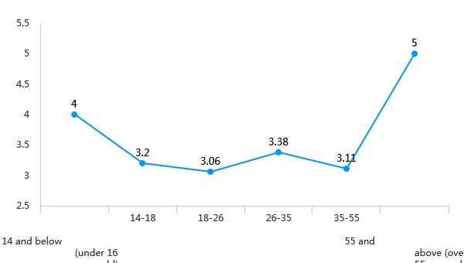

Question 18 (Sub-question 5):In-game rewards to encourage prosocial behavior in the gaming community (overall evaluation, 1 point is very bad) [Matrix question]

|  |  |  |  |  |  |  |  |  |
| --- | --- | --- | --- | --- | --- | --- | --- | --- |
| X\Y | don't know unknow | very worse | poor worse | normal | better nice | very nice very nice | Subtotal | The average score |
| 14 and below (under 16 years old) | 3 (33.33%) | 0 (0.00%) | 0 (0.00%) | 0 (0.00%) | 4 (44.44%) | 2 (22.22%) | 9 | 2.89 |
| 14-18 | 6 (28.57%) | 0 (0.00%) | 2 (9.52%) | 3 (14.29%) | 5 (23.81%) | 5 (23.81%) | twenty one | 2.76 |
| 18-26 | 13 (11.02%) | 10 (8.47%) | 14 (11.86%) | 30 (25.42%) | 37 (31.36%) | 14 (11.86%) | 118 | 2.93 |
| 26-35 | 4 (10.81%) | 3 (8.11%) | 6 (16.22%) | 6 (16.22%) | 15 (40.54%) | 3 (8.11%) | 37 | 2.92 |
| 35-55 | 3 (25%) | 1 (8.33%) | 1 (8.33%) | 5 (41.67%) | 2 (16.67%) | 0 (0.00%) | 12 | 2.17 |
| 55 and above (over 55 years old) | 3 (75%) | 0 (0.00%) | 0 (0.00%) | 0 (0.00%) | 0 (0.00%) | 1 (25%) | 4 | 1.25 |

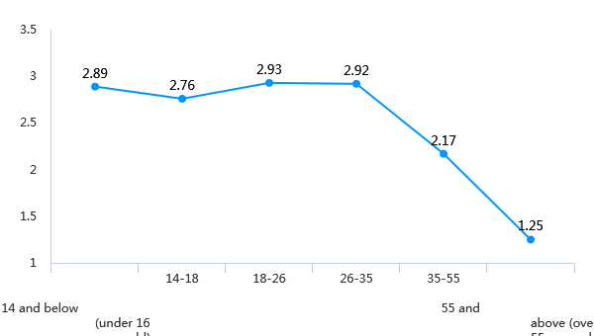

Question 20 (Sub-question 5):Temporary or permanent ban and/or forced withdrawal from game if found at fault (overall evaluation, 1 point is very bad) [Matrix question]

|  |  |  |  |  |  |  |  |  |
| --- | --- | --- | --- | --- | --- | --- | --- | --- |
| X\Y | don't know unknow | very worse | poor worse | normal | better nice | very nice very nice | Subtotal | The average score |
| 14 and below (under 16 years old) | 3 (33.33%) | 0 (0.00%) | 0 (0.00%) | 0 (0.00%) | 4 (44.44%) | 2 (22.22%) | 9 | 2.89 |
| 14-18 | 5 (23.81%) | 0 (0.00%) | 0 (0.00%) | 5 (23.81%) | 6 (28.57%) | 5 (23.81%) | twenty one | 3.05 |
| 18-26 | 10 (8.47%) | 7 (5.93%) | 10 (8.47%) | 44 (37.29%) | 29 (24.58%) | 18 (15.25%) | 118 | 3.09 |
| 26-35 | 4 (10.81%) | 3 (8.11%) | 5 (13.51%) | 11 (29.73%) | 8 (21.62%) | 6 (16.22%) | 37 | 2.92 |
| 35-55 | 4 (33.33%) | 0 (0.00%) | 1 (8.33%) | 3 (25%) | 4 (33.33%) | 0 (0.00%) | 12 | 2.25 |
| 55 and above (over 55 years old) | 3 (75%) | 0 (0.00%) | 0 (0.00%) | 0 (0.00%) | 0 (0.00%) | 1 (25%) | 4 | 1.25 |

